28. Phylogenetic Inference and Systematic Methods (*RHM:* *Chapter 24)*

______________________________________________________________________________

### I. Introduction *(550-551)*

A. Biodiversity

B. The Bigger Questions

C. Systematics : study of the kinds and diversity of organisms and all of their evolutionary relationships

1. definition

-Taxonomy: classification and practice of classifying orgasms

2. taxonomy

Taxon – group of organisms that from a category in a classification which is a system for organizing our knowledge of organisms

-Nomenclature- process of naming organisms

3. phylogenetic reconstruction

-Branching design that illustrates common ancestry

D. Importance of Systematics to Biological Sciences

II. Taxonomy, Classification and Nomenclature *(551-552)*

1. The Linnaean System

-18th Century (100 years before Darwin)

B. Information Retrieval

-The purpose of classifying organisms is to identify where it falls in the classification

-Felidae- a family of mammals including all cats

C. General Form of a Classification

1. nested hierarchy

-Made up of boxes within boxes

2. formal categories

3. inconsistency of taxonomic levels

D. Classification as a Reflection of Phylogeny

1. Assumption of monophyly

2. Recency of common ancestry

3. Inconsistency of taxonomic levels

-polyphyletic taxon: domestic cats and dogs in one group

-goal is create monophyletic taxon

III. Phylogenetic Reconstruction *(552-560)*

1. Form of Phylogenetic Trees

-Classify based on genes not appearance

-Cladistics proposes every speciation events starts with one ancestor and produces two directions

-Each branching point represents a common ancestry and is called a node

-All species descended from a common ancestor are called a clave

B. Reading Phylogenetic Trees

C. Sources of Data for Phylogenetic Reconstruction

-External/internal anatomy

-Behavior

-And variety of other characteristics because we believe these reflect the underlying genetics

-DNA sequencing commonly used now

D. Homology *versus* Homoplasy

-Homologous: if the similarities were inherited from a common ancestor

-Homoplastic: similarities from any other cause (not interested in using these for shared ancestry)

- Homology: built of similar materials, develop in similar places in the body, and similar embryo structure

-Character polarity: the direction I which … changed characteristics (ancestral vs derived)

-Adaptive radiation

-Outgroup comparison. ID organisms of study. Find outgroup. Compare similar trait to outgroup. ID ancestral condition. Other condition is derived.

IV. Constructing Phylogenetic Trees *(561-567)*

A. Traditional Approaches

B. Phylogenetic Systematics and Cladistic Methods

1. character polarity

2. synapomorphies

3. principle of parsimony

V. Phylogenetic Trees and Classification *(560-561)*

A. Problems with Traditional Approaches

B. Phylogenetic Classification

C. PhyloCode

28-1

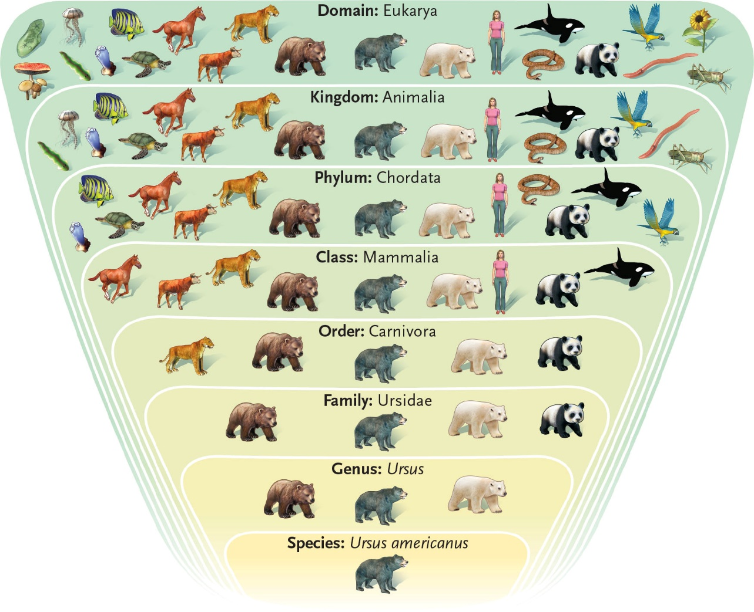

28-2

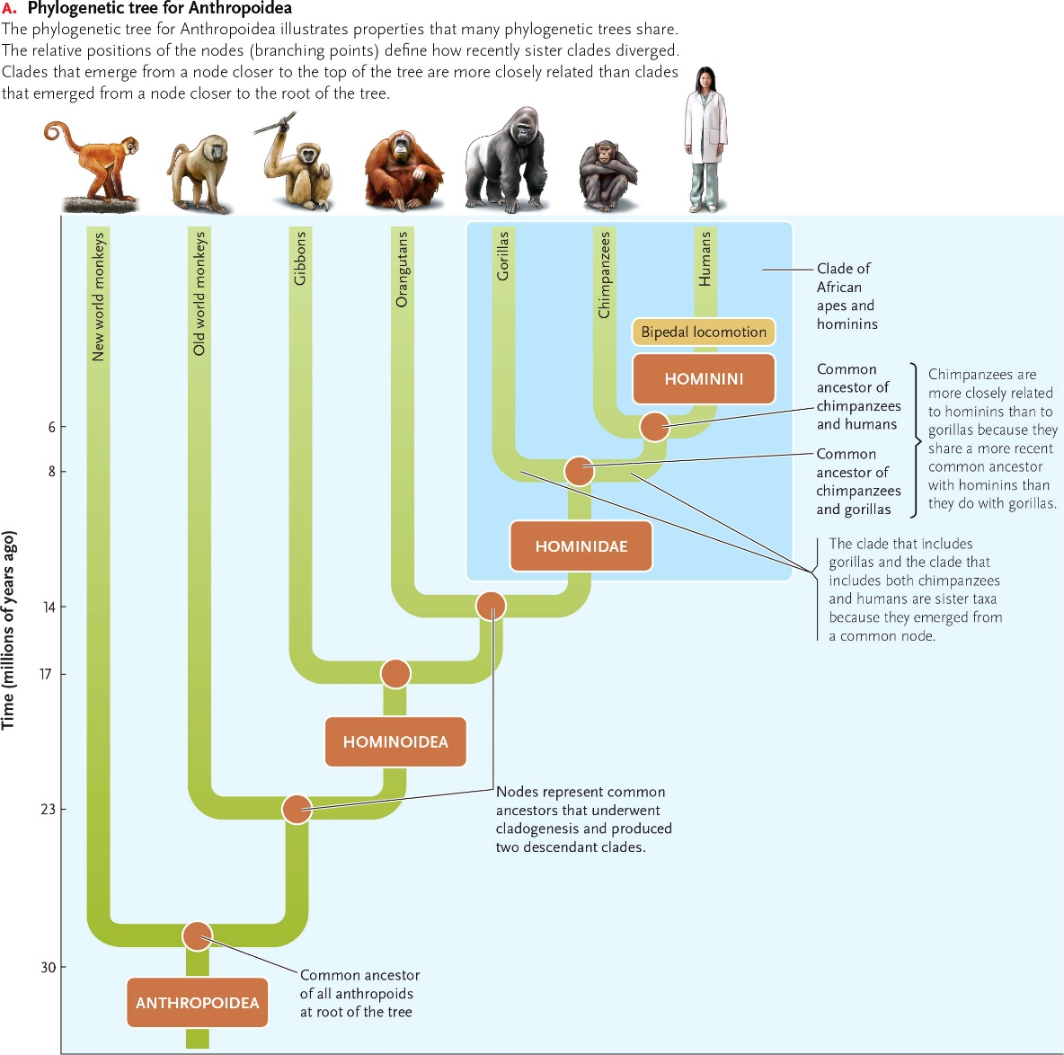

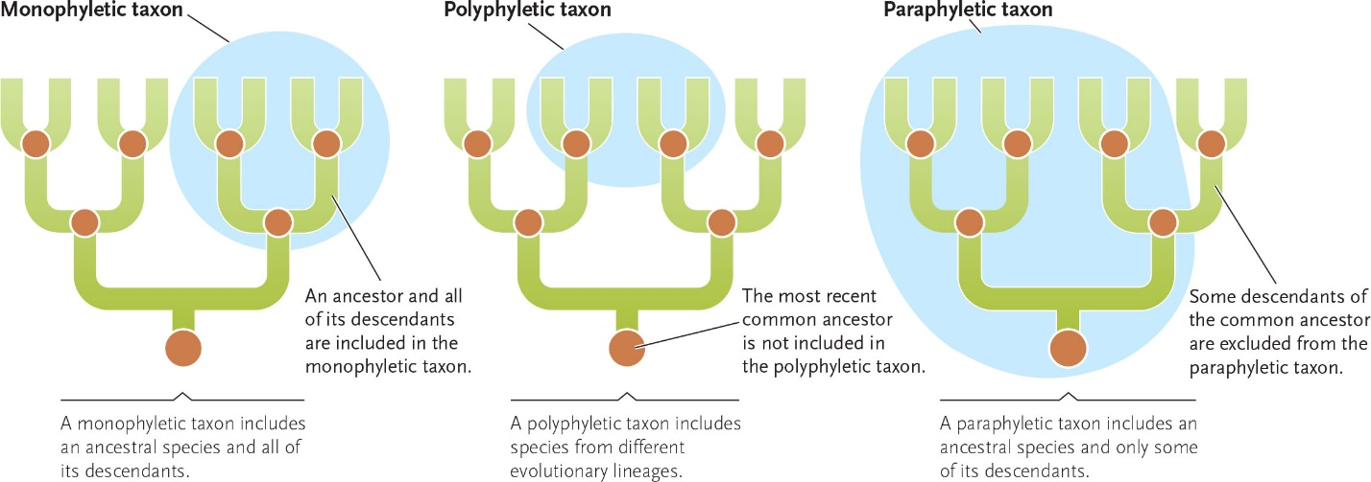

28-3

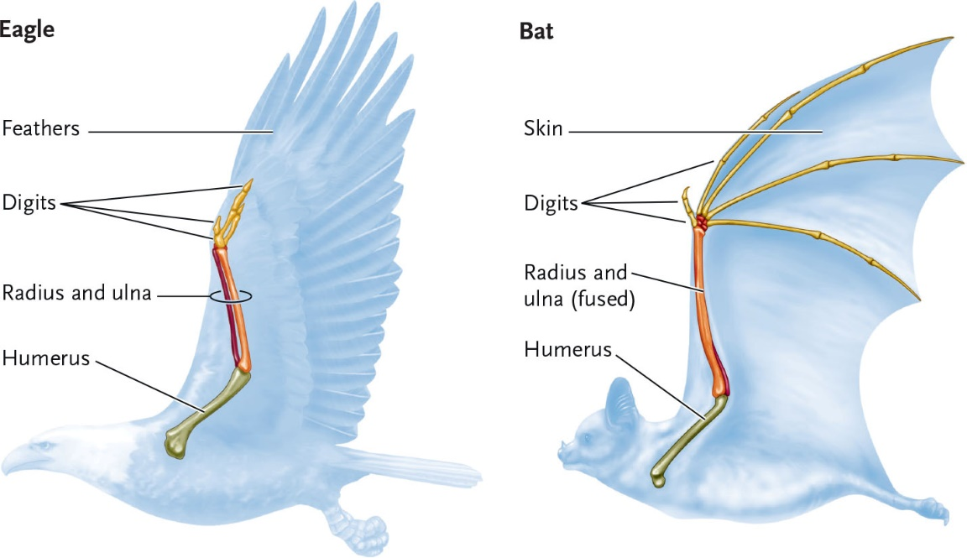

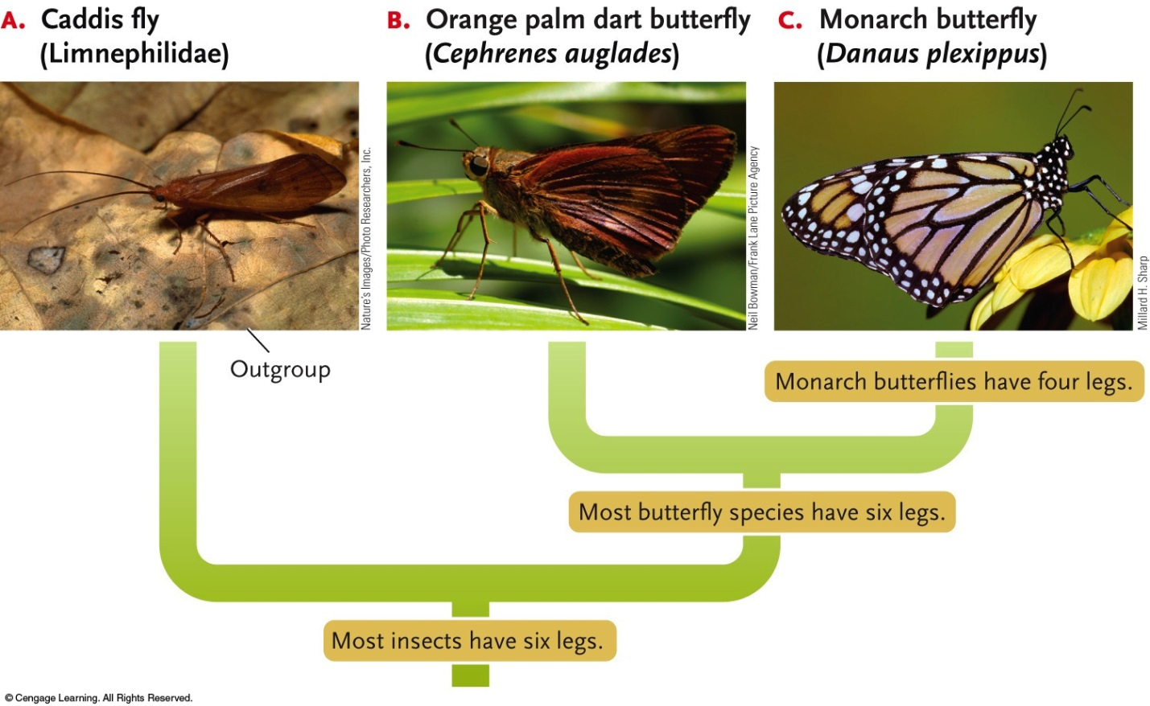

28-4

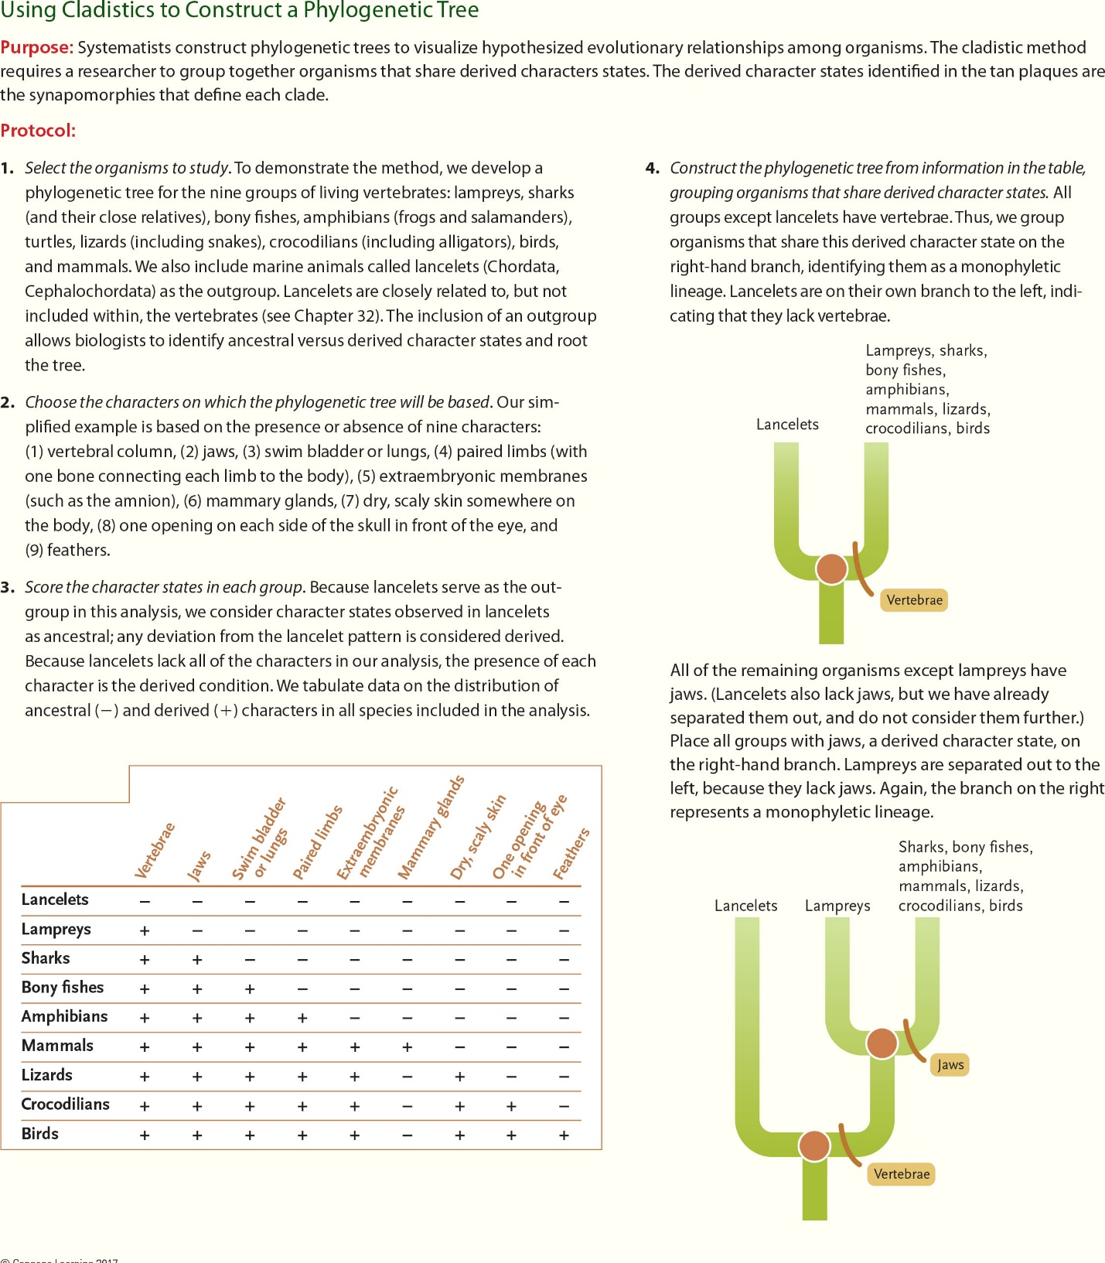

28-5

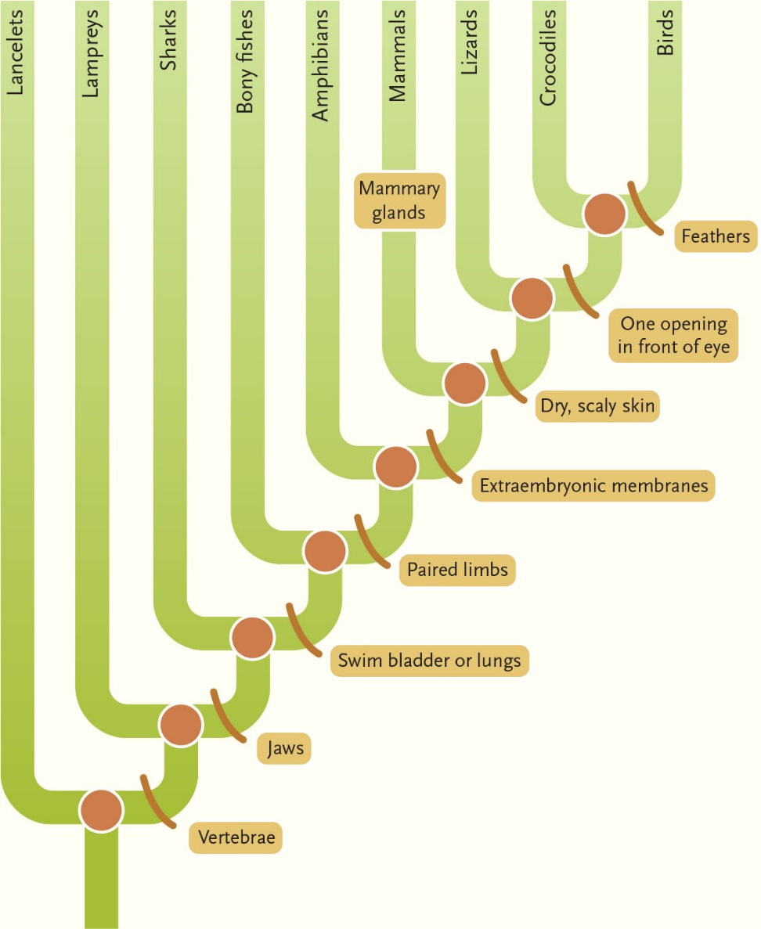

28-6

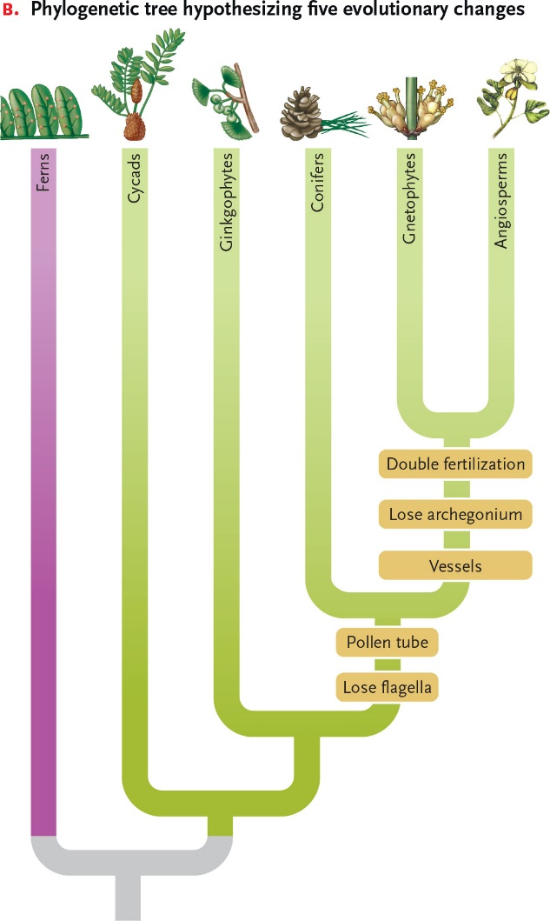 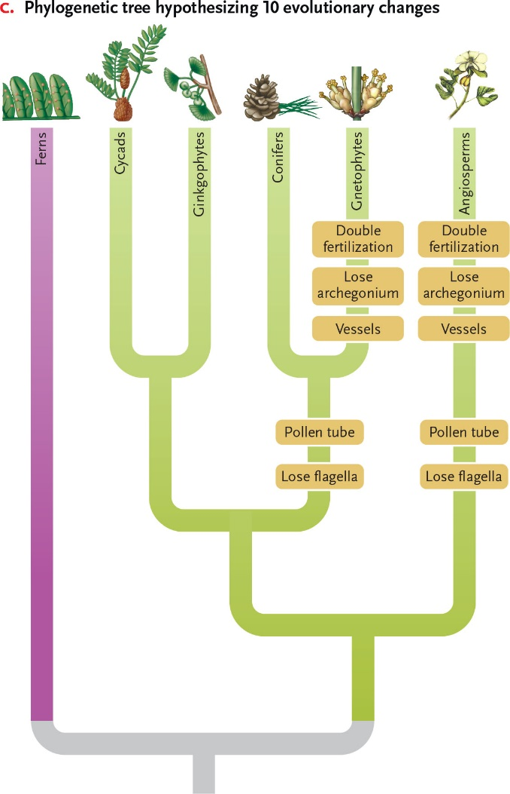

28-7

